create database employe;
use employe;
create table dept( deptno int primary key,dname varchar(45),
dloc varchar(50));
create table emp
( eno int,
ename varchar(45) not null,
mgr_no int,
hiredate date,
sal decimal,
deptno int,
primary key(eno),foreign key(deptno) references dept(deptno));
create table project( pno int primary key,
pname varchar(34), ploc varchar(23
));
create table assignes_to (eno int,dno int,pno int,jobrole varchar(34),primary key(eno,pno),
foreign key(eno) references emp(eno),
foreign key(pno) references project(pno));
create table incentives(eno int,incentive_date date,inc_amount decimal,foreign key(eno) references emp(eno));
insert into dept values(10,"HR","mumbai"),(20,"finance","delhi"),(30,"research","mysuru"),(40,"sales","bangalore"),(50,"marketing","hyderabad"),(60,"ÏT","CHENNAI");
INSERT INTO EMP VALUES(101,"RAJU",NULL,"2019-03-12",550000,10),(102,"SNEHA",101,"2020-07-19",34567,20),(103,"KIRAN",101,"2021-01-25",423000,10),(104,"PRIYA",102,"2022-05-10",40000,30),(105,"ARJUNA",103,"2023-09-15",389900,20);
INSERT INTO PROJECT VALUES(1,"äpollo","bengaluru"),(2,"orion","hyderabad"),(3,"zenioth","mysuru"),(4,"logic hub","pune"),(6,"äudit system","delhi");
insert into assignes_to(eno,dno,pno,jobrole)
values(101,10,1,"project manager"),(102,50,2,"software engineer"),(103,30,3,"analyst"),(104,20,4,"äccountant"),(105,50,6,"co ordinator");
insert into incentives values(101,"2000-09-23",50000),(102,"2005-09-18",90987),(103,"2005-03-21",8900),(104,"2005-03-9",7899),(105,"2005-03-7",5488),(104,"2005-09-2",9808);
insert into incentives values(101,"2000-01-23",50000),(102,"2005-01-18",90987),(103,"2005-01-21",8900);
delete from incentives where eno=101;
tables
select* from dept;
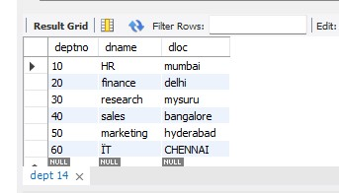
select*from emp;
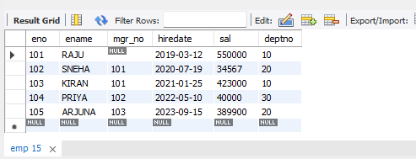
select* from incentives;
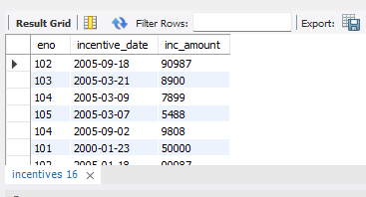
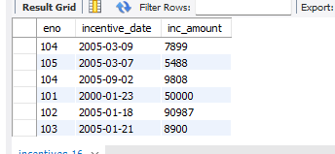
select* from assignes_to;
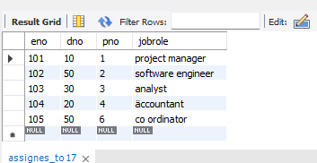
select * from project;
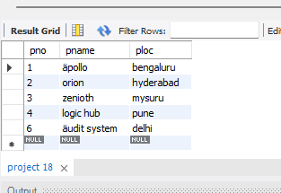
i. Retrieve the employee numbers of all employees who work on project located in Bengaluru,
Hyderabad, or Mysuru
select distinct eno
from assignes_to where pno in(select pno from project where ploc in("bangalore","mysuru","hyderabad"));
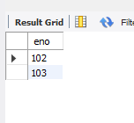

ii. Write a SQL query to find the employees name, number, dept, job_role, department location
and project location who are working for a project location same as his/her department
location.

select e.eno,e.ename,e.deptno,a.jobrole,d.dloc,p.ploc
from emp e,dept d, project p, assignes_to a
where e.eno=a.eno
and e.deptno=d.deptno
and p.pno=a.pno
and d.dloc=p.ploc;
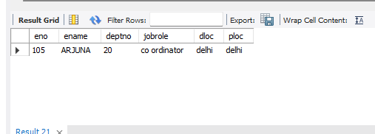
iii. Get Employee ID’s of those employees who didn’t receive incentives
select distinct eno,ename from emp where not exists(select 1 from incentives where emp.eno =eno);
